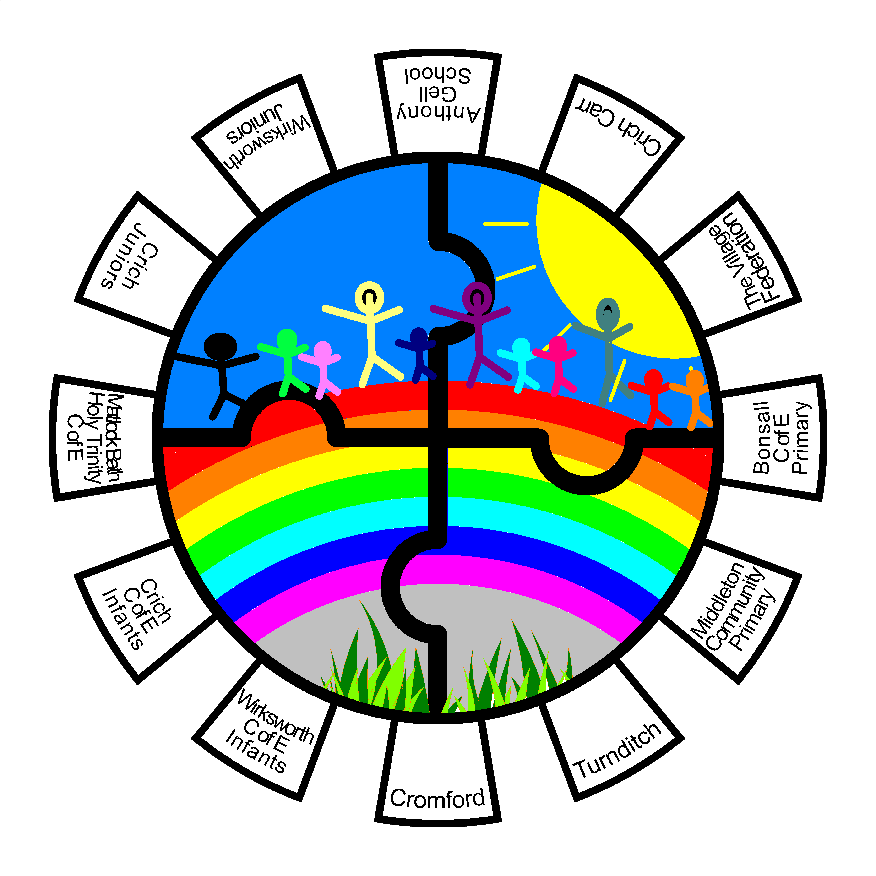
Our school is part of the
Cluster of Gell Schools (CoGS)
This leaflet provides some information about CoGS. To find out more please go to the CoGS page on your school website or ask your Headteacher or Chair of Governors.
CoGS (Cluster of Gell Schools) is a strong and supportive group of schools made up of Anthony Gell School and the Primary Schools in the surrounding area.

Based on longstanding relationships between the schools, CoGS was formally created in 2016. Since then, it has gone from strength to strength as an arrangement which greatly benefits the children and families of our communities.

Each of our 14 schools is represented by the Headteacher and a Governor, who co-ordinate and develop our work.

Our schools remain independent and retain their uniqueness and ethos, but we see many advantages in the CoGS family supporting each other and sharing best practice.

CoGs Aims 2025/26: -
“To improve educational outcomes for the students of all of the schools in the Cluster”.

We will:
- Work in close partnership to provide a wider range of educational opportunities.
- Improve transition between schools by closer joint working across the cluster.
- Improve outcomes for students supported by pupil premium funding and those with special educational needs.
- Improve training opportunities available to school staff and governors by networking and the sharing of expertise.
- Share financial advantages of group purchasing that may be available.

CoGS Schools:
- Anthony Gell School
- Bonsall CE (VA) Primary School
- Brassington Primary School
- Carsington & Hopton CE Primary School
- Crich CE Infant School
- Crich Junior School
- Crich Carr CE Primary School
- Cromford CE Primary School
- Kirk Ireton CE Primary School
- Matlock Bath Holy Trinity CE Primary School
- Middleton Community Primary School
- Turnditch CE Primary School
- Wirksworth CE Infant School
- Wirksworth Junior School

Current projects include:
- Cluster school art project displayed as part of Wirksworth Arts Festival.
- Cluster Science project led by Anthony Gell School as part of National Science Week,
- Moderation of our assessments to ensure a common standard to aid transition between phases of education.
- Collaborative sports events, e.g. Olympic Run
- Shared Cluster INSET day to develop expertise and opportunities for children.

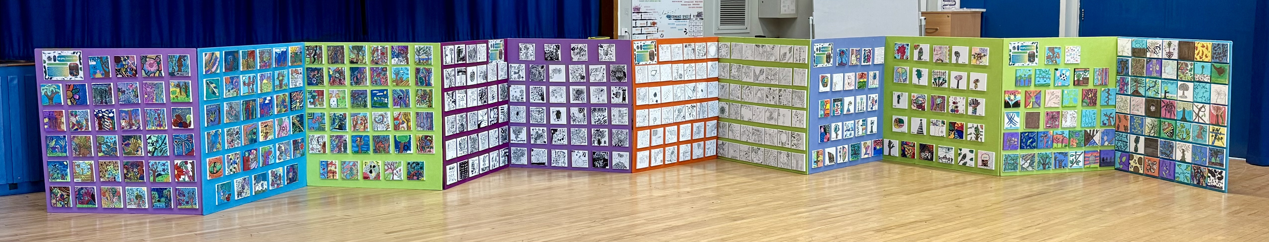
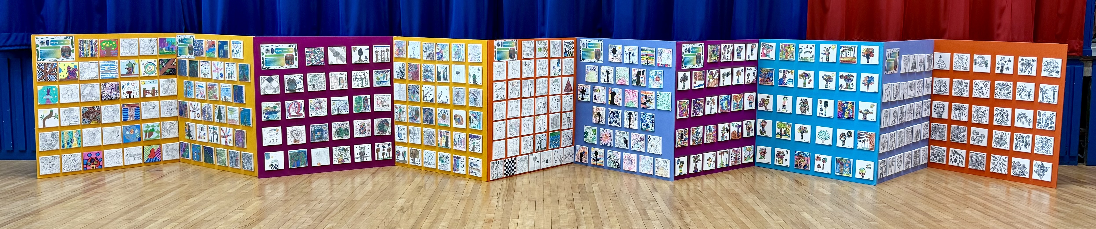
COGS Cluster Art Project – September 2025

